HUMA Analysis

<https://journals.lww.com/jtrauma/fulltext/2023/08000/evaluation_of_vascular_repair_by_tissue_engineered.11.aspx>

* HUMA released pre-clin study looking at ATEV/ HAV vs ePTFE in porcine model
* N=36 pigs, 4 treatment groups
  + receiving either the HAV or a PTFE graft following a hind limb ischemia period of either 0 or 6 hours
  + 3cm by 6mm
  + In right eliac artery
  + Not immune suppressed for 1st mth
  + Eval: graft patency, hind limb function, biochem markers/ histology
  + Hind limb function and tissue damage biomarkers improved?
* Multiple typos in paper
* In methods say PTFE not ePTFE
* Paper below says infection rates wont be different btwn synth and nat
* Embolisms?
* 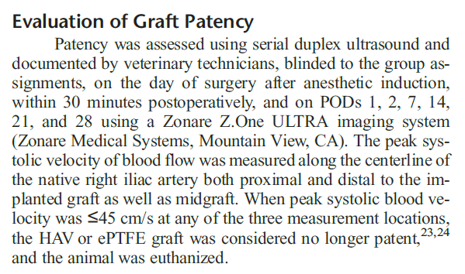

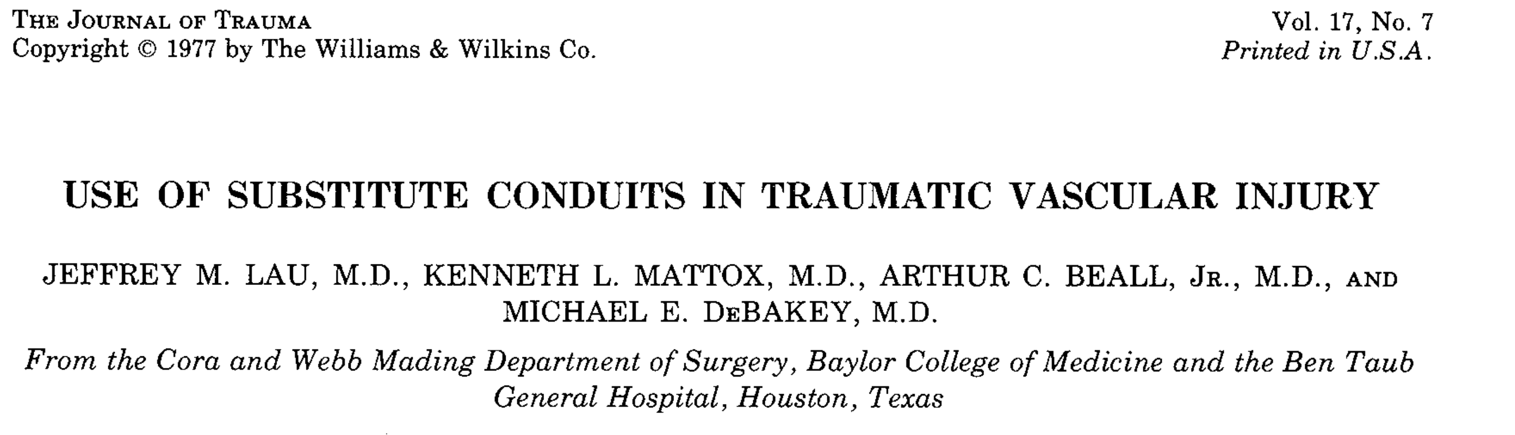

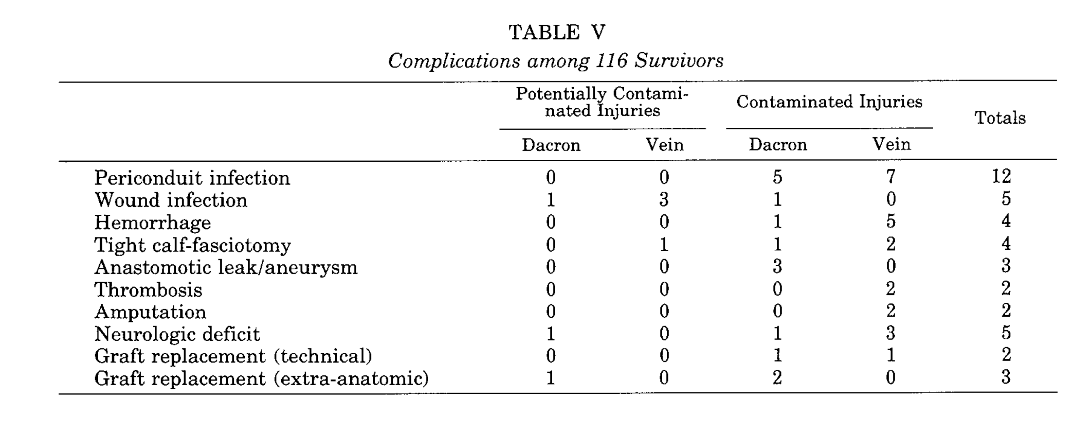

Rates of infection don’t differ much between synthetic and saphenous veins

https://www.ncbi.nlm.nih.gov/pmc/articles/PMC7768973/

* Vein grafts constituted 82% of the repairs and had a similar estimated patency of 93% compared with 81% for all other repairs.
* Proportion of scripts that are vein vs PTFE/ other?
* Upper extremity arterial cohort: Vein grafts constituted 90% of the repairs and had a patency of 97% compared with 33% for all other repairs (p<0.001; only five repairs were in this group).
* Lower extremity arterial patency: Lower extremity estimated arterial repair patency was 91% with median follow-up of 20 months

chrome-extension://efaidnbmnnnibpcajpcglclefindmkaj/https://www.fda.gov/media/158495/download

PTFE graft BLA

Meta analysis studies

Local response-

* Only have one rat study for local response.
* N=15, they report no foreign body giant cells (FBGCs) at

Devices:

* PTFE
* ePTFE
* HePTFE
  + Below-knee bypass 48mths primary patency: HePTFE 45.2% vs ASV 69%, p<0.001
  + Secondary patency: 57% HePTFE vs 67.5% ASV, p=0.1

HC Wainright call 09/10/2024

* Have treated 600 pts? Data??
* 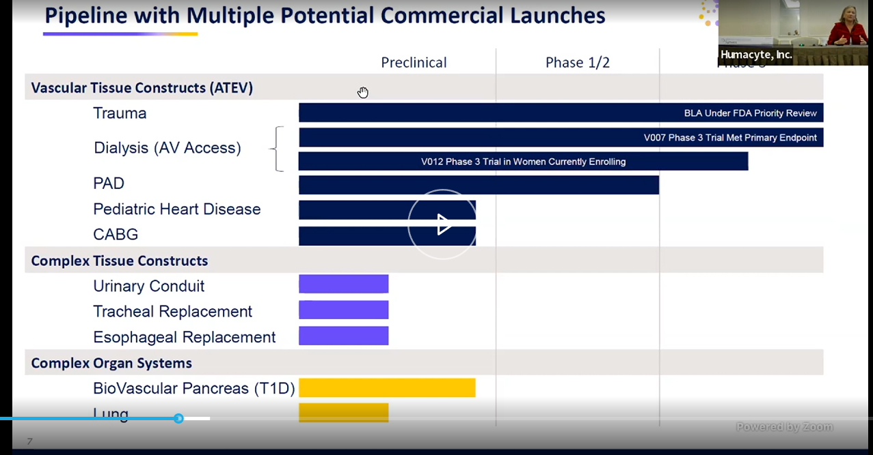
* DOD supported ph3 trial in BLA submission
* 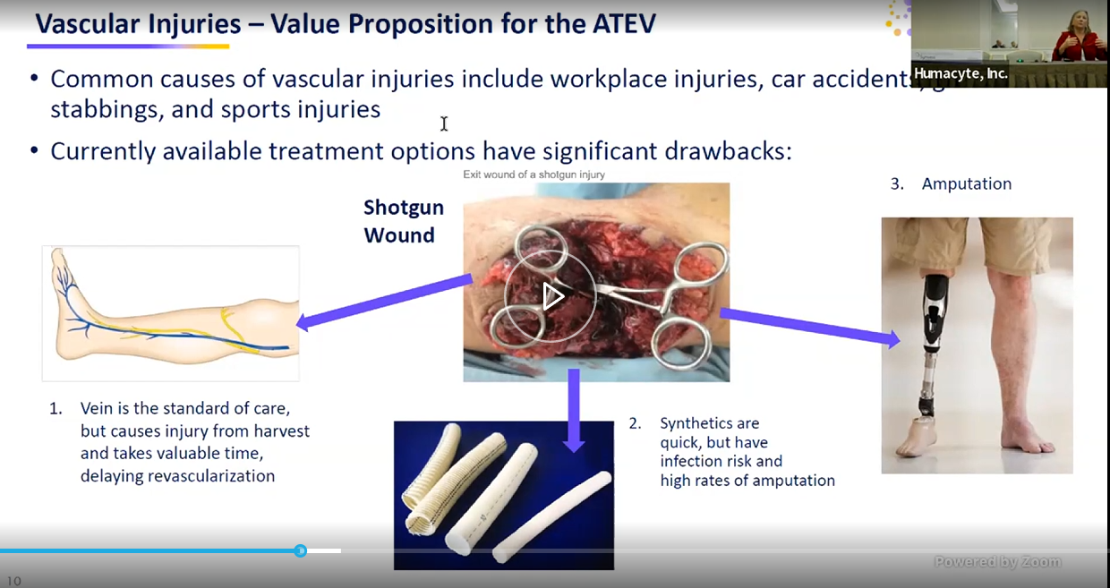
* She says infection rate is “quite high” on grafts vs their approach
* 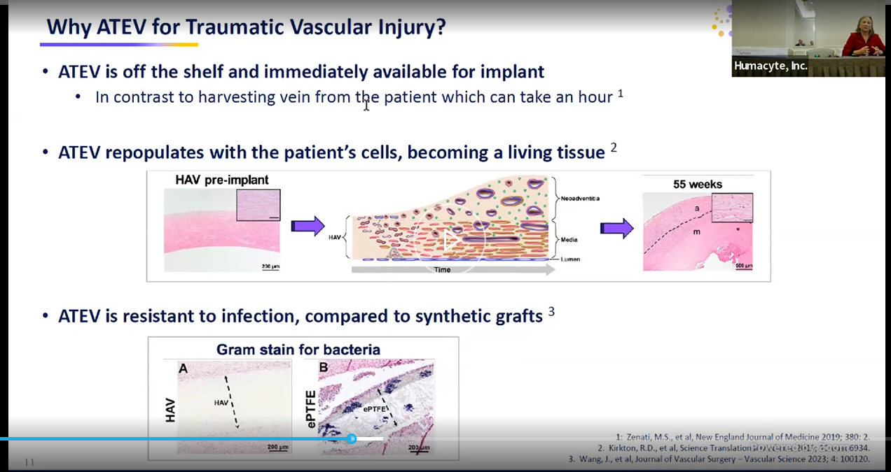
* 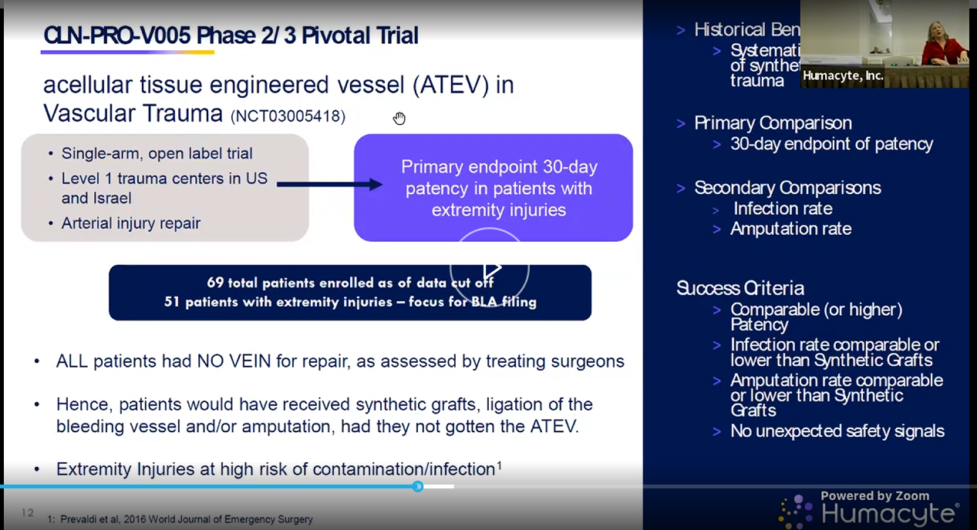
* Will follow pts for 3yrs on this study
* 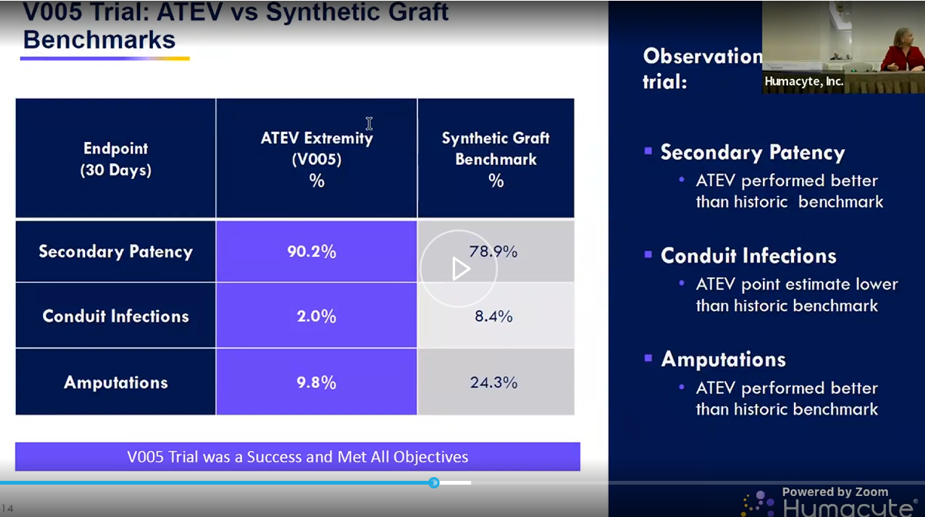
* 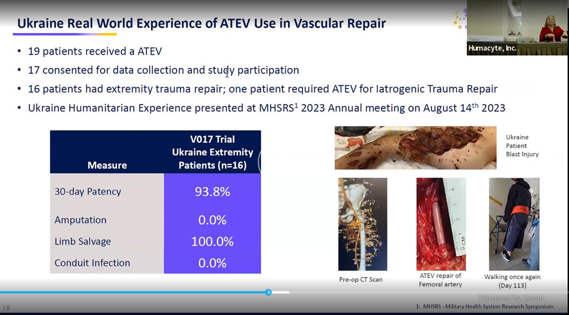
* Docs trained over zoom?
* 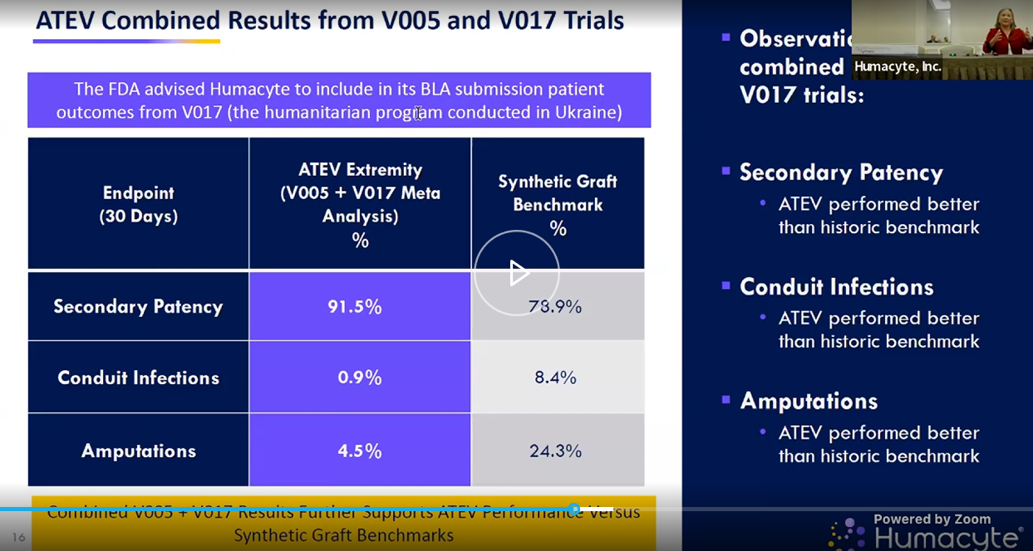
* 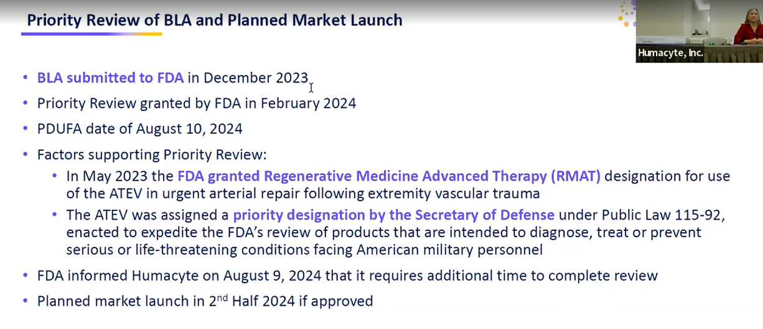
* “we’ve completed inspections and labelling talks and post approval commitments w FDA”
* “we do not have a new PDUFA data, expect to hear in coming weeks and months”
* 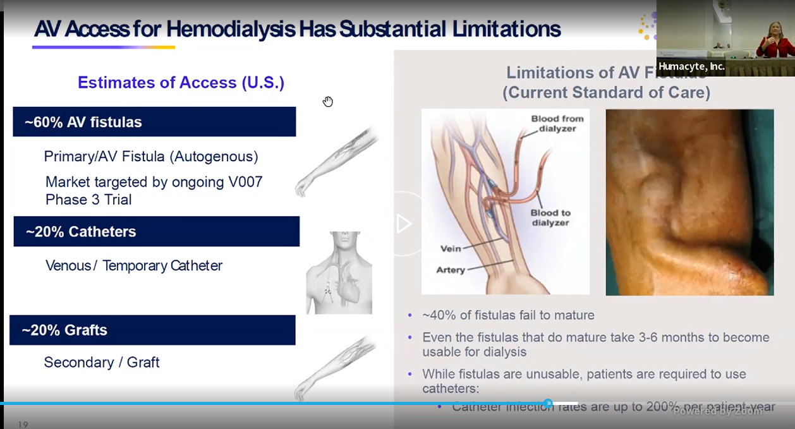
* 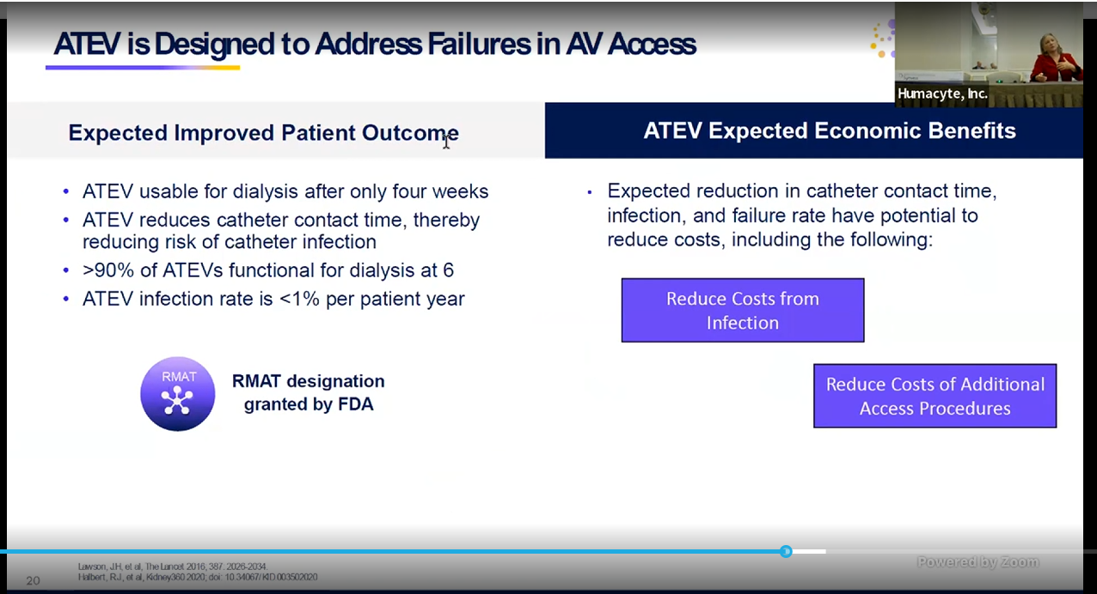
* 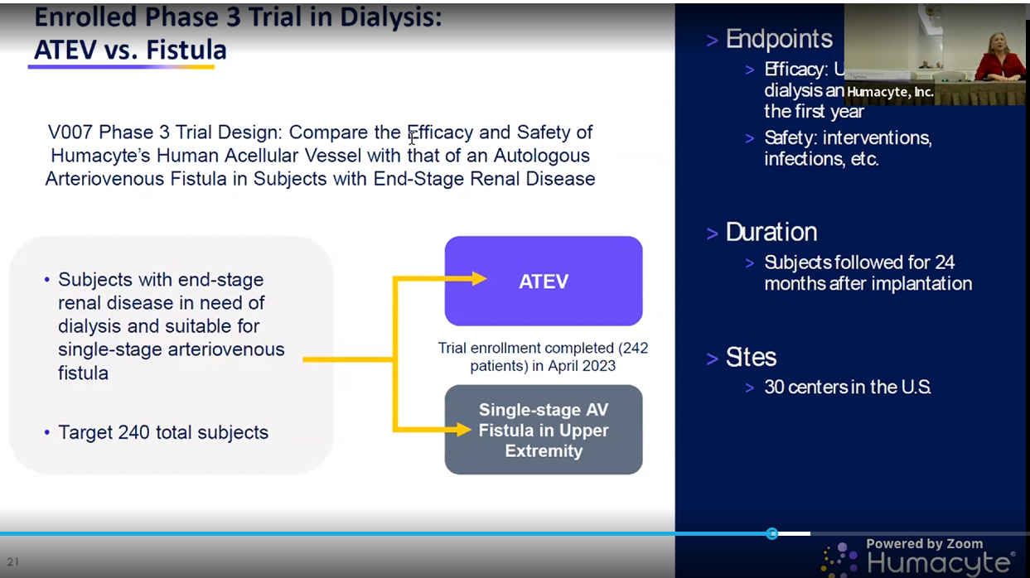
* 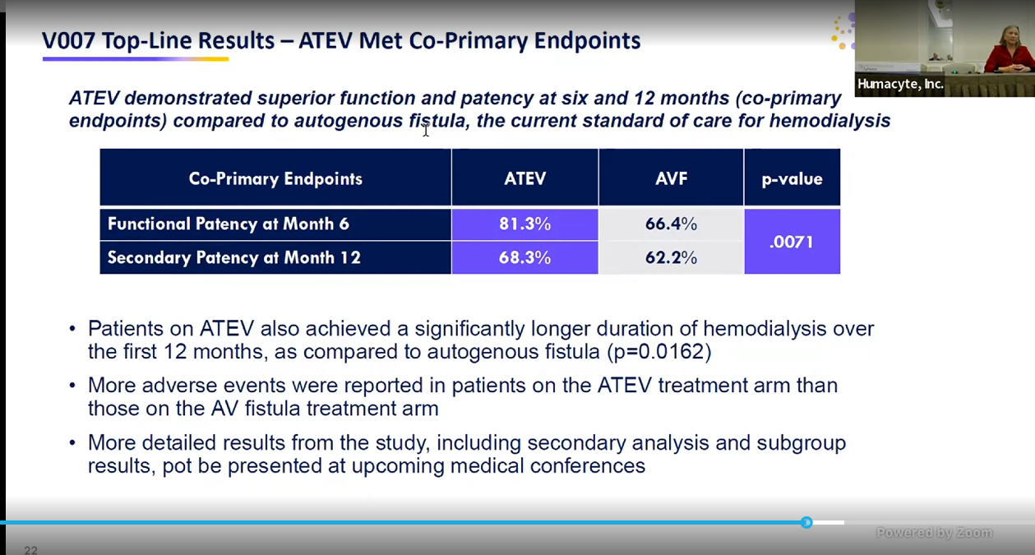
* Also have sub groups they are keen to share those with us soon! In several weeks at KOL webinar
* This study is done already
* 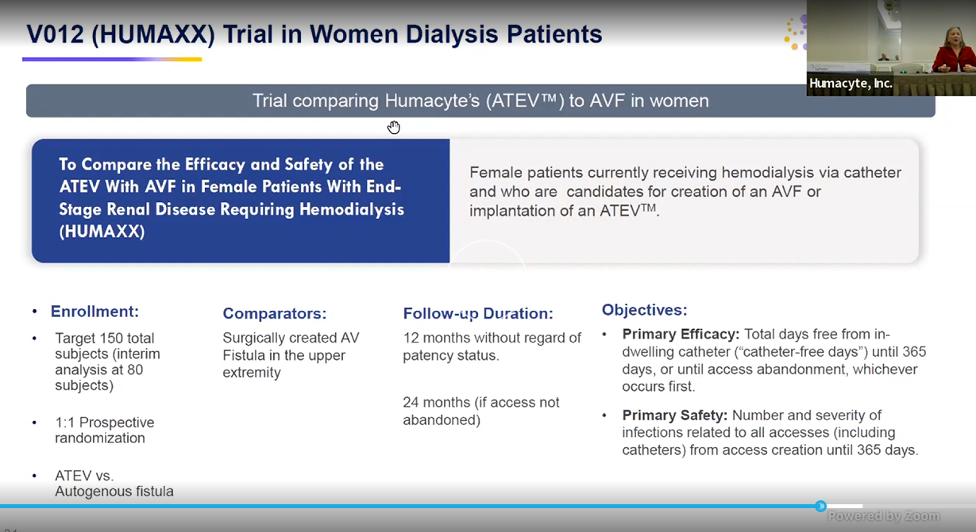
* 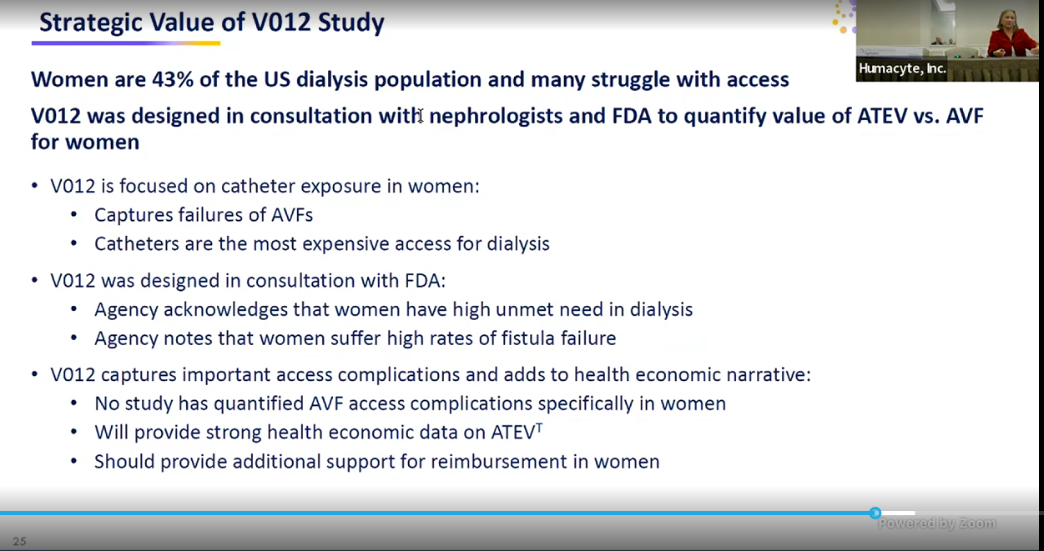
* 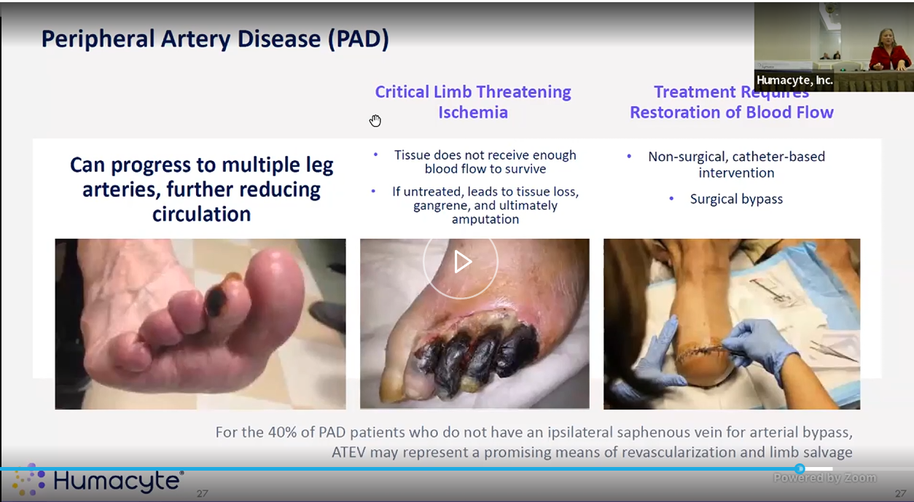
* Skipped thru the following
* 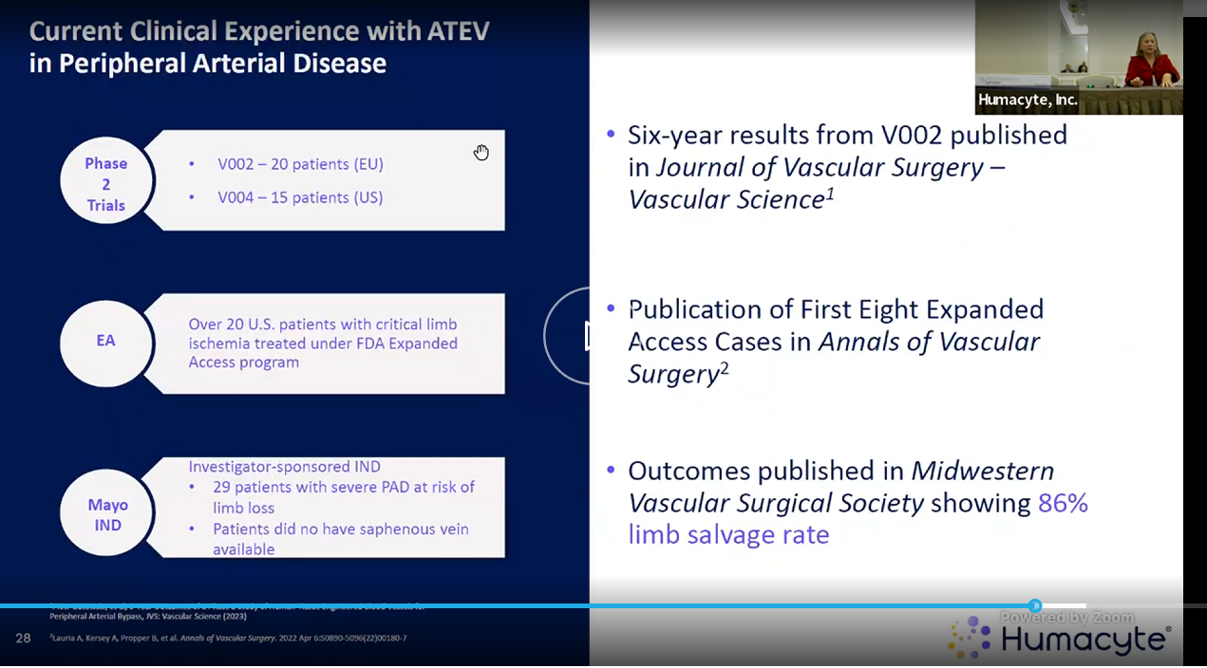
* 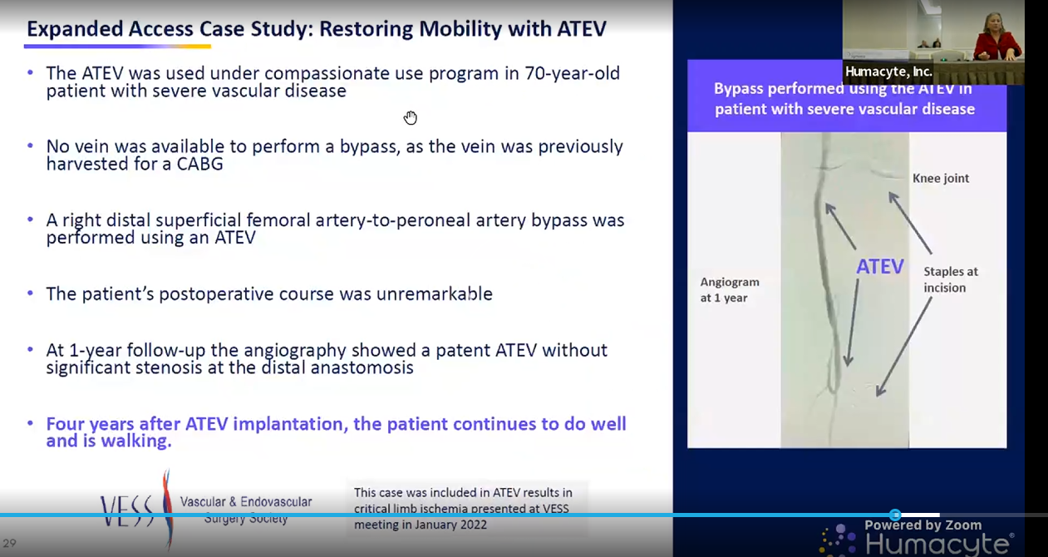
* 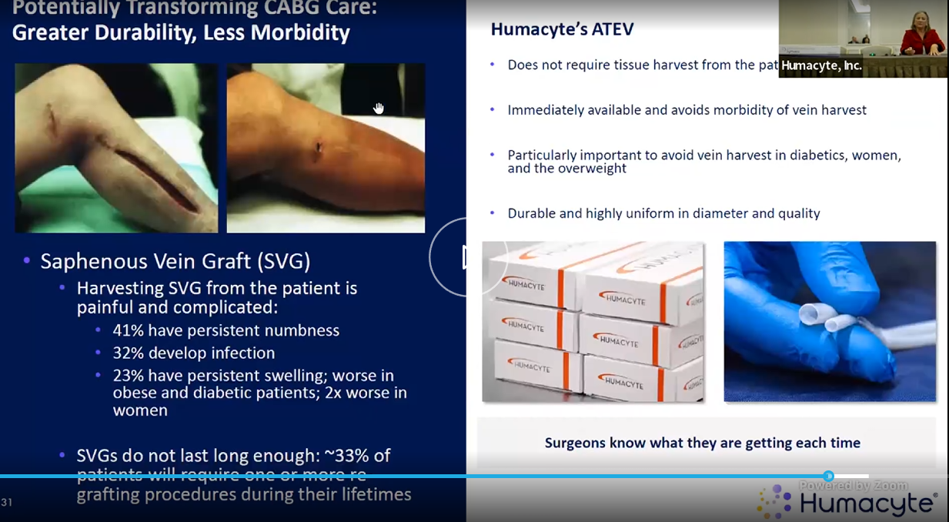
* 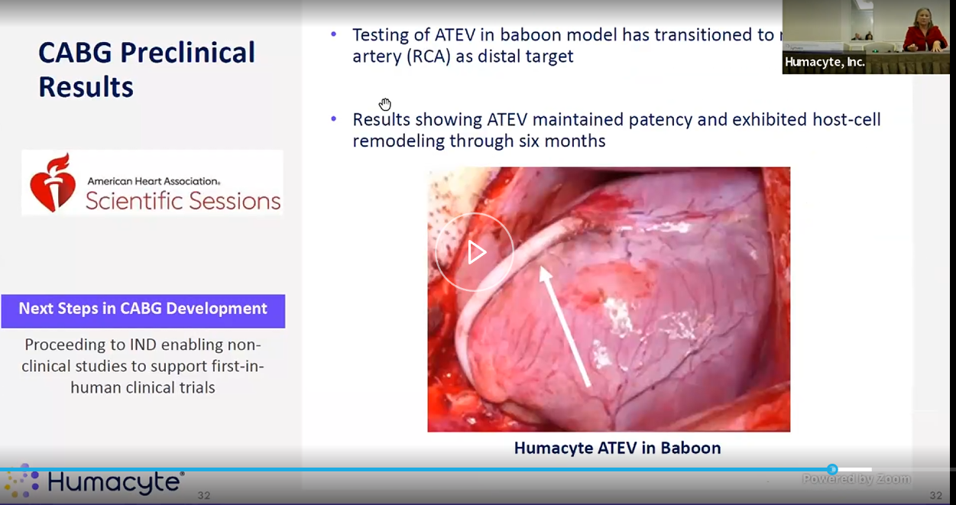
* 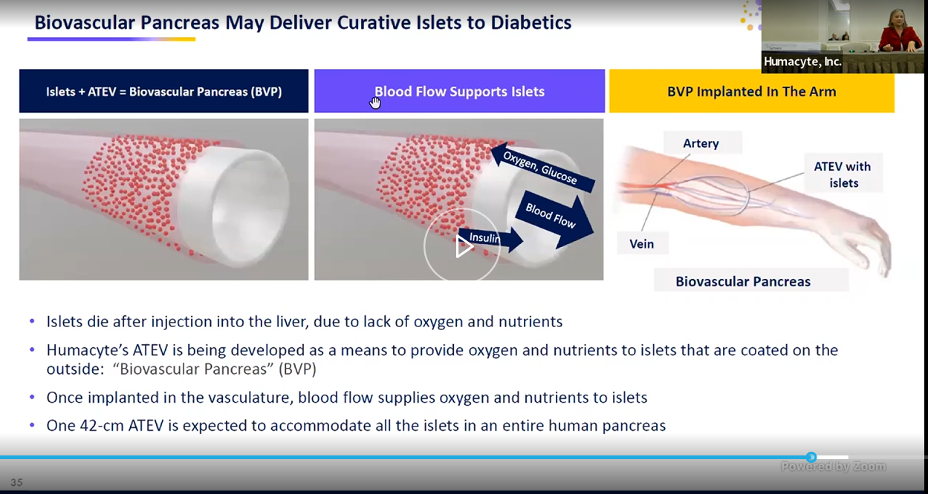
* 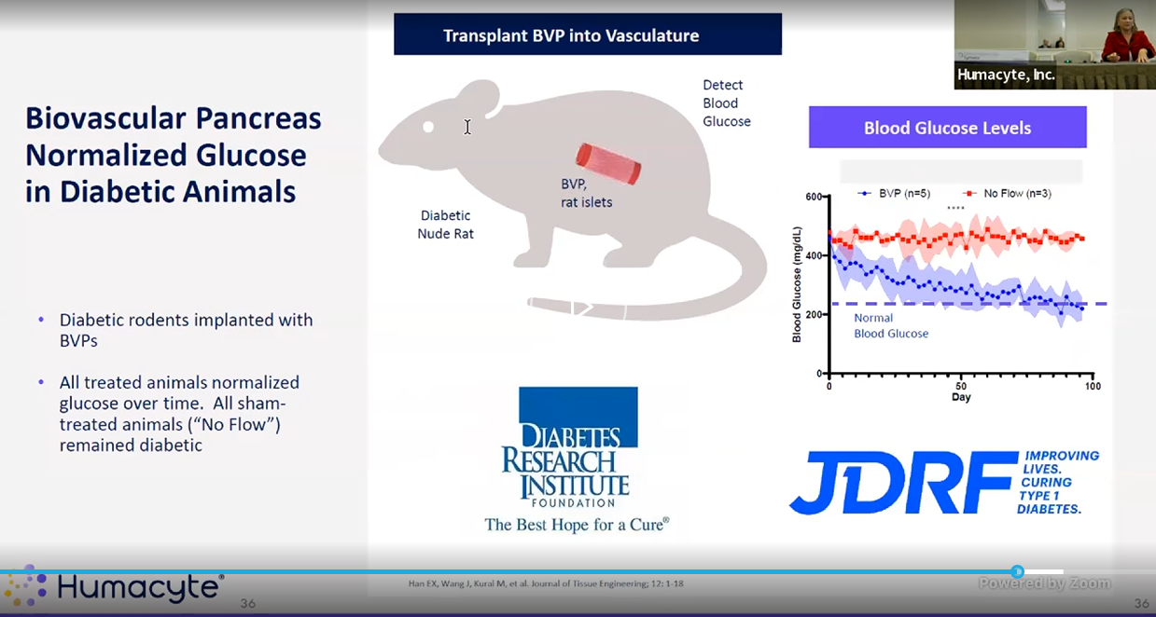
* 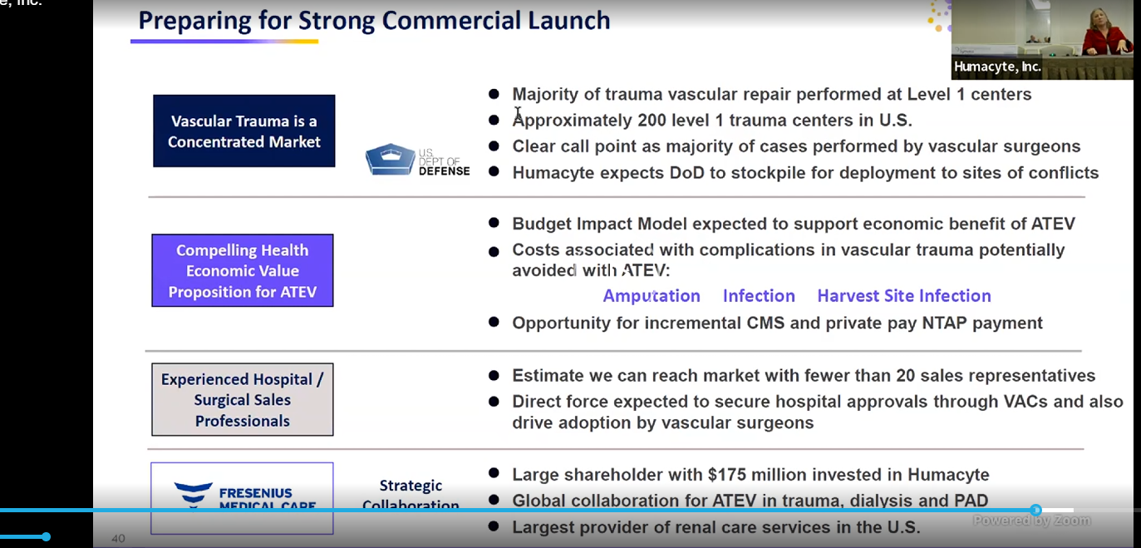
* 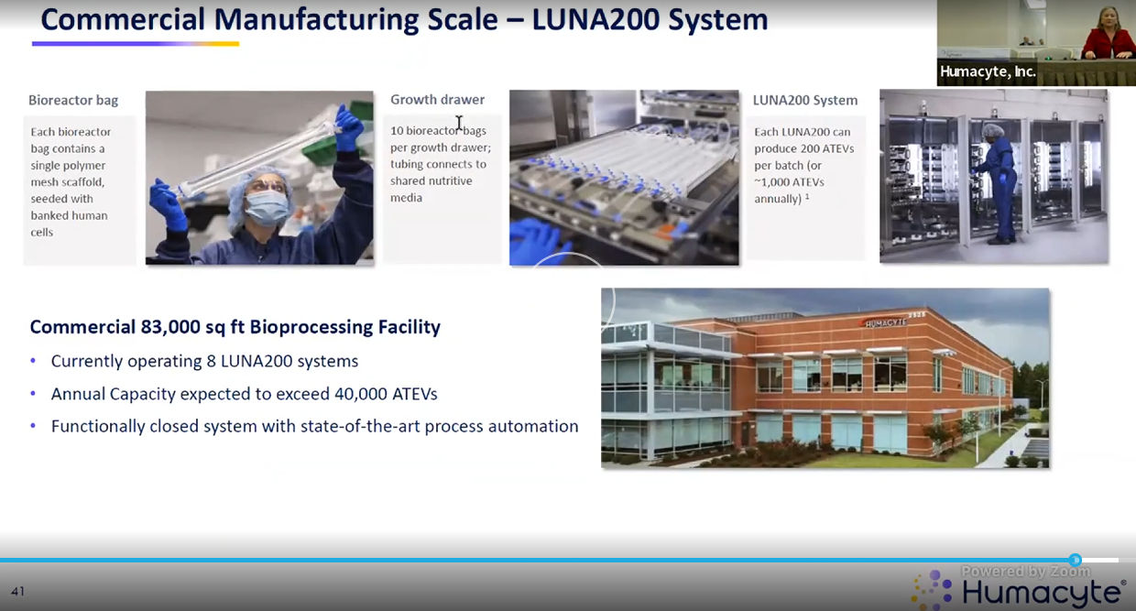
* 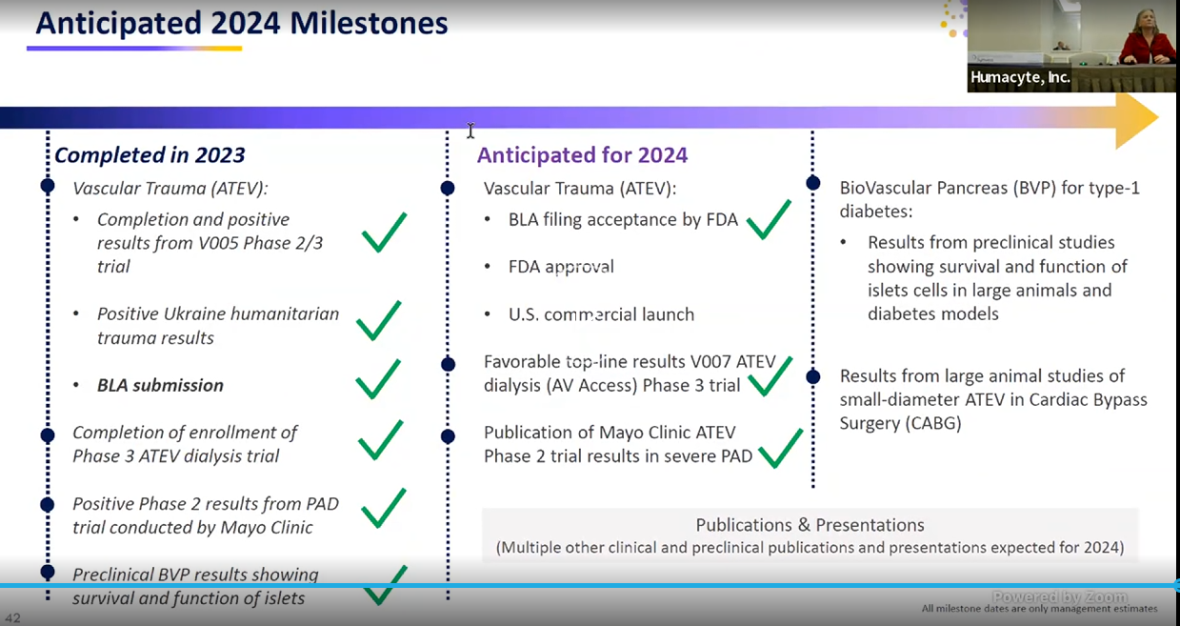
* 20% of facility is actually occupied rn. Rest can be expanded.

Patency:

Primary patency means that you perform a procedure to restore patency to a vessel, and report how long patency is maintained without any repeat intervention. Primary-assisted patency defines the durability of an intervention that failed initially but not to the level of thrombosis and was retreated. Secondary patency means that the initial intervention failed to the level of thrombosis and was retreated.

https://www.ncbi.nlm.nih.gov/pmc/articles/PMC2386712/  
**Hemodialysis Arteriovenous Fistula Patency Revisited: Results of a Prospective, Multicenter Initiative**  
Primary patency is the intervention-free access survival. Assisted primary patency is the thrombosis-free access survival. Secondary patency ends when the access is abandoned

Risk factors for primary functional patency loss (intervention-free interval) and secondary failure (abandonment) were determined using regression models.

Primary patency (intervention-free access survival) was defined as the interval from time of access placement to any intervention designed to maintain or reestablish patency or to access thrombosis or the time of measurement of patency

Assisted primary patency (thrombosis-free access survival) was defined as the interval from time of access placement to access thrombosis or time of measurement of patency, including intervening manipulations (surgical or endovascular interventions) designed to *maintain* the functionality of a patent access

Secondary patency (access survival until abandonment) was defined as the interval from time of access placement to access abandonment or time of measurement of patency, including intervening manipulations (surgical or endovascular interventions) designed to *reestablish* the functionality of thrombosed access

The word “**functional**” was added to patency to indicate that patency interval started at date of first successful cannulation for hemodialysis treatment instead of date of access placement

Thesis: HUMA is a sell candidate due to its lack of clinical efficacy, questionable safety data and overall lack of data for the indication they are pursuing for approval with their BLA. This thesis relies primarily on an evaluation of the clinical data of the trauma and dialysis indications.

* State the lead product, mention indications it’s pursuing.
* Set context for the indications- patency (define them), and how FDA’s mandate is to approve on safety and efficacy. We will examine both of those perspectives when considering the approval of the ATEV.
* Efficacy- trauma
  + Look at clinical data – V005, V017
    - V005
      * ~~introduction~~
      * ~~Clin readout table~~
      * ~~Inclusion exclusion criteria~~
      * ~~Endpoints~~ 
        + ~~What they are now~~
        + ~~What they started as~~
    - Historical comparisons
      * VAVIS study and data
        + Anti platelet meds
        + Patency at 30days as bridge

Argue that one

* + - * + Lower body vs upper body
        + Gunshot vs blast
      * Their own historical comparison in slides
    - Anti platelet drugs
    - V017
      * Complete lack of inc/excl
      * Ukranian, retrospective, observational
      * Highest reported data ever
      * Endpts
        + Limited time for comparison, 30d, 12m
      * N=16
* Safety- trauma
  + Amputations, infections
* Efficacy- Dialysis
  + V006
    - Endpts
      * Functional patency is a made up term
      * Secondary patency
  + V007
* Safety
  + No long term data in any case
  + Infection and amputation rates at what timeline? 30d??
* Finances
* Selling by board member and husband of CEO

HUMA’s lead product is the acellular tissue engineered vessels (ATEV), an artificial vein which is being investigated in many applications but we will look at the two lead indications which are in ph3 clinical trials. Because of the company’s short term cash position the near term clinical catalysts and regulatory approvals will likely determine the outcome of the stock in the next year or so which will be the focus of this analysis.

To do this analysis we will consider predominantly the clinical efficacy and safety.

In considering the efficacy of an artificial vein there are some key metrics to evaluate to determine its clinical effectiveness. Michael Jaff [talk abt his article]. So we have concluded that patency is the key endpoint to assess the efficacy of this intervention. Beyond patency for efficacy, we will have to consider safety of the device. The safety outcomes reported by the company focus primarily on amputations and infection rates, so we will examine those in more detail.

The BLA submitted to the FDA includes two studies as supporting evidence for its approval, V005, and V017.

V005

From the current version of the published study we can read that this study is a prospective, interventional, multicenter, multi-cohort, non-randomized phase 2 study being conducted in civilian populations across the United States and Israel. It aimed to evaluate patients with life of limb-threatening vascular trauma. There is a torso (thoracic) cohort, as well as a limb (extremities) cohort. The expected study enrollment period was 24mths, with follow-up evaluation being 36mths. Total enrollment was 72 patients, which started 2018-09-01 (exp enrollment completion 2020-09-01) should have follow-up data then 3yrs later for long term efficacy readout, 2023-09-01.

There are inclusion and exclusion criteria, but we will focus in on a few:

Inclusion:

* Autologous vein graft is either not feasible in the judgment of the treating surgeon (e.g. because of lack of availability of suitable conduit, presence of severe venous insufficiency) or is not desirable because of the urgency of revascularization

Exclusion:

* Mangled Extremity Severity Score (MESS) of ≥ 7
* Limb at high risk of amputation despite vascular reconstruction (e.g., because of crush injury)
* Catastrophic injuries that make survival unlikely (e.g. Abbreviated Injury Scale (AIS) > 5 or Injury Severity Score (ISS) >60)
* Known medical condition which would preclude long term antiplatelet therapy after resolution of acute injuries

They have also shared some topline data but we are well served to consider their endpoints in the study as well as any edits that have been made over the years.

Primary endpoints

* HAV primary patency, 30days
  + Known medical condition which would preclude long term antiplatelet therapy after resolution of acute injuries
* Frequency and severity of AEs, 36mths

Secondary endpoints

* Primary patency, primary assisted patency, secondary patency at 36mths
* Limb viability (whether amputated or not)

The original study design submitted in 2016 (before the trial started) considered many primary endpoints: 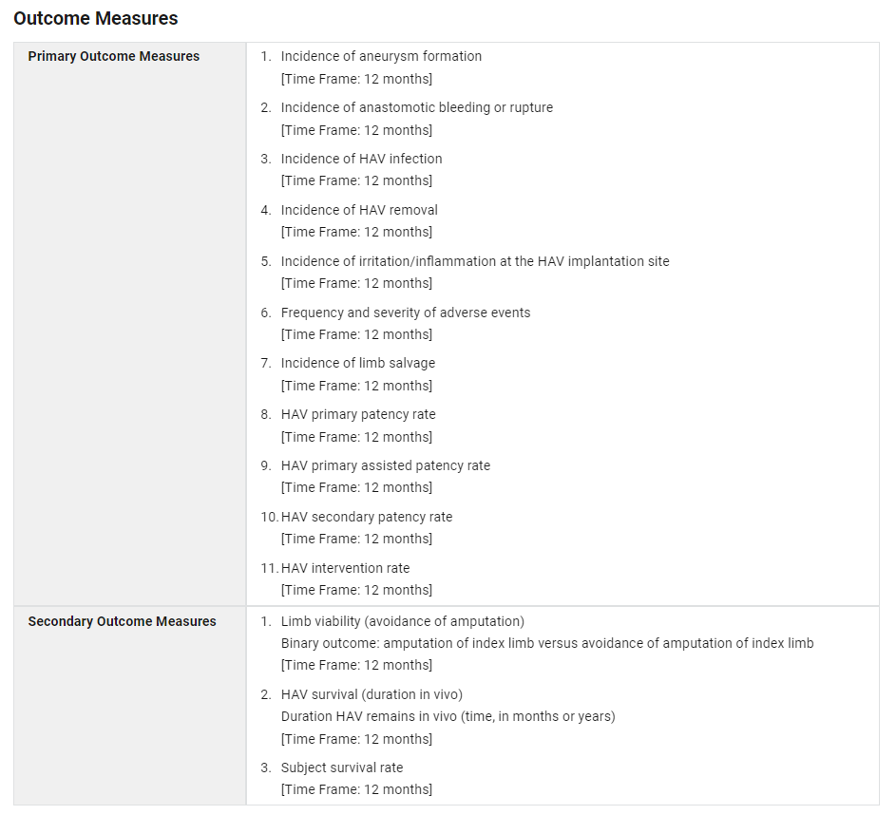

Which was updated 1 month ahead of study enrollment in 2018. Although this was just the initial submission, I do find it odd that they had initially set up this study with 11 primary endpoints. Primary endpoints are supposed to be, primary, and take precedence over secondary endpoints in terms of weight and importance to the study in question. Listing 11 primary endpoints smells a lot like endpoint chasing. I acknowledge that they changed the protocol ahead of enrolment but I worry that this reveals some intent in their choice of parameters for this clinical trial.

Moving on from that, we should explain a bit more about what patency means (and doesn’t’ mean) before we begin to look at the results.

Patency

We can look up the definition of patency on google for a quick answer; the quality or state of being open or unobstructed [mirriam webster] but we’re better served by reading papers on the topic to understand its use in medical vernacular. Obviously, Humacyte in this clinical trial are examining several defined versions of patency.

We have primary patency, primary assisted patency, and secondary patency. From the clinical trial itself:

*Primary patency is defined as 'the interval from the time of access placement until any intervention designed to maintain or reestablish patency, access thrombosis or the measurement of patency', i.e., patent without interventions*

*Primary assisted patency is defined as 'the interval from the time of access placement until access thrombosis or the time of measurement of patency, including intervening manipulations (surgical or endovascular interventions) designed to maintain the functionality of patent access' i.e., patent without an intervention to clear a thrombus*

*Secondary patency is defined as 'the interval from the time of access placement until access abandonment', i.e., patent with or without interventions*

These definitions are in alignment with other sources [1,2,3].

To break them down a different way, we can think of primary patency as the vessel being put in the patient and not requiring any intervention nor having any thromboses. Primary assisted is when a thrombotic event has occurred, and one needs to have an intervention to re-establish patency. Secondary patency is from the time of placement in the patient until it is removed.

Patency is really important as a metric because it’s essentially telling us whether or not the vessel is still working, and to what extent uptake has been required to keep it patent. These will be important in how we think about the use of the HAV/ ATEV in clinical practice.

Results

The final enrolment for the study was 72, but only 51 total patients were included in the evaluable population. This is because there was a choice to remove the thoracic patients entirely from the analysis and only consider the extremity patients in the evaluable cohort. So the final study V005 relies on the n=52 cohort.

They in their PR on 2023-12-12 reported the following topline data:

|  |  |  |  |
| --- | --- | --- | --- |
|  |  | HAV | lit rev synth graft |
| 30day secondary pat | | 90.20% | 78.90% |
| primary pat (time??) | | 84.30% | NOT POSSIBLE |
| amputation rate |  | 9.80% | 24.30% |
| infection |  | 2.00% | 8.40% |

In their public facing material they do not cite their historical comparisons explicitly. This includes their PRs, their recent slide decks, and any published works on behalf of Humacyte or CEO Laura Niklassen. However, I have dug up an older version of their slide deck from the SEC archives which does cite some of their sources for their claims.

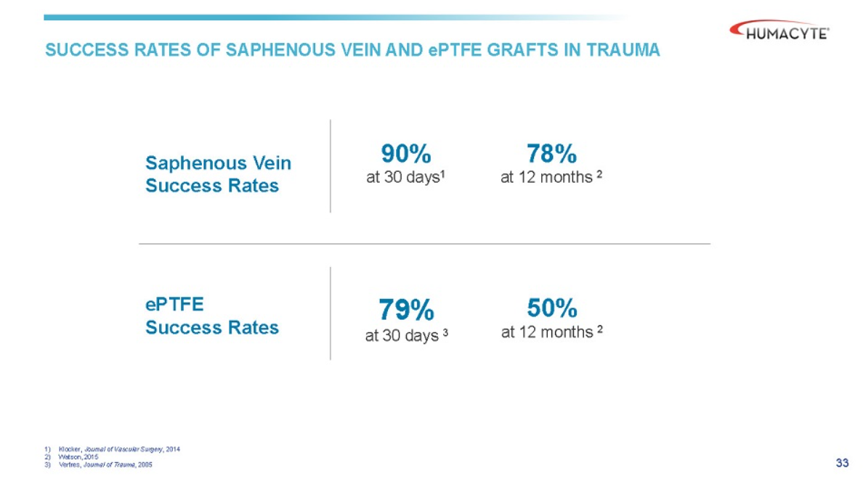

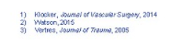

These studies comprise all the content I could find which signalled their “historical comparison”, or “Synthetic Graft Benchmark”. Let’s go through them.



Study 3. Is the key to their claim as it remained primarily unchanged in the efficacy endpoint comparator. This is a single n=14 study that examines the use of a PTFE graft as a tempering intervention in the battlefields of Iraq and Afghanistan to allow soldiers to vascularize their tissues in the short term and then get to a US medical center and receive an autogenous venous graft thereafter.

There was some balance between gunshot (n=6) and blast injuries (n=6), while most injuries were lower body (n=8), some upper body (n=3), and some thoracic (n=3). They state the mean time to stateside arrival was 7 days (range 3-9d), and that within that short period of time 79% of prosthetic grafts stayed patent. 4 cases were presumed to have been infected (28.5%), and it states that no patients require amputation due to graft failure but 3 patients (21%) elected to choose lower extremity amputation due to non-salvageable limbs.

I find this choice of data also surprising as a “historical comparison” when I have found other such studies examining the use of prosthetic grafts in wartime injuries, same as the above Vertrees study. I present this 2020 paper by Haney et al. [4] which examines data from the VAVIS (VA Vascular Injury Study) study [5].

This study was specifically looking at extremity vascular injuries in veterans of the Iraq and Afghanistan conflicts, and how well grafts had performed in the trauma setting. This was a cohort of 527 patients, 140 of which had imaging studies for 143 arterial repairs. Most (52%) were from explosions, and (42%) gunshot wounds. 81% of the 143 repairs were vein grafts and eight repairs 5.6% were occluded, replaced or included in extremity amputations. Patency rates were observed in the cohort:

|  |  |
| --- | --- |
| Patency |  |
| 3m | 99% |
| 6m | 97% |
| 12m | 95% |
| 24m | 91% |
| 36m | 91% |

They then conclude that

*Arterial repair mid-term patency in combat-related extremity injuries is excellent based on imaging studies for 143 repairs.*

Long term data

The biggest concern with the ATEV data released thus far is the long-term data follow-up.

Because this is a military study we can con

For lots of obvious reasons this is not a great comparator arm to base an FDA approval decision off of. I also do not believe it is an earnest attempt to communicate what a literature review would reveal the all stakeholders. To me, this is a deliberate attempt to present favorable data that does not agree with broader published results and it’s a big reason why I’m writing this.

and they have not yet published the full account of the clinical data used in their BLA submission.